HEARTFELT® | MODULAR FELT CEILING SYSTEM
Hunter Douglas Architectural created the ceiling that needed to be made: HeartFelt®. A modular felt ceiling system with unparalleled acoustic and visual properties. Eye and ear-pleasing design with a sustainable origin.

General Information
Why HeartFelt®
HeartFelt® is an innovative, patented product that turns every ceiling into a visual and acoustic playground. HeartFelt® linear felt ceiling panels are available in round and box-shaped panels, and can easily be clipped to the specially designed carriers.
In addition to the box-shaped panels in a height of 55mm, the grey tones are also available for the box-shaped panels in heights of 80mm and 105mm, and the round panels in a height of 64mm.
The modular system along with a wide range of options in terms of colour and height offer designers a host of design options and variations.
Characteristics
- Great acoustic performance
- Five different grey tones and five earth tones for a warm ambience
- Available in heights of 55, 64, 80 and 105 mm
- Easy installation and low risk for damages
- 100% recyclable or easily reusable
- Cradle to Cradle Certified™ Bronze (Cradle to Cradle CertifiedTM is a certification mark licensed by the Cradle to Cradle Products Innovation Institute).
- Easy to maintain: dirt and dust resistant
Application
HeartFelt® is suitable for most building sectors: Corporate, Retail, Leisure, Public space, Hospitality, Healthcare, Education or Residential .
Please contact us to discuss your requirements.

Design & Inspiration
Inspired by felt as an intriguing material for clothing, furniture, and fashion accessories, with the HeartFelt® ceiling system, Hunter Douglas is providing architects, installers and building owners with an advanced system that allows them to create the right ambiance and to precisely manage the acoustics of every space.

COLOURS
Shades of grey & Earth tones
The felt panels are available five shades of grey and five earth tones. The exact shade of the panels is determined by the ratio of white and black fibres in the basic material.

Five shades of grey
WHITE 7593 | LIGHT GREY 7596 | MIDDLE GREY 7597 | DARK GREY 7598 | BLACK 7594
Earth Tones
 | 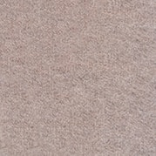 | 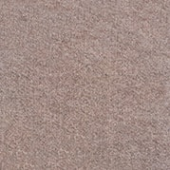 |  | 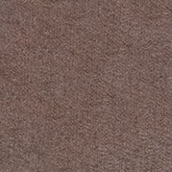
CREME 7575 | LIGHT BROWN 7576 | MEDIUM BROWN 7577 | DARK BROWN 7578 | UMBER 7579
If you need a different color then above please contact us.
* There might be small colour differences compared to real samples.

PRODUCT DETAILS
Material characteristics
HeartFelt® is a linear ceiling system made of non-woven thermoformed PES fibres with open joints between the panels. The box-shaped panels are available in heights of 55mm, 80mm and 105mm. The round panels are available in a height of 64mm. All HeartFelt® panels have a maximum length of 6000mm. The following modules are available: 50 - 200mm in increments of 10mm.
End Cap
If desired Heartfelt® panels can be closed with an end cap.
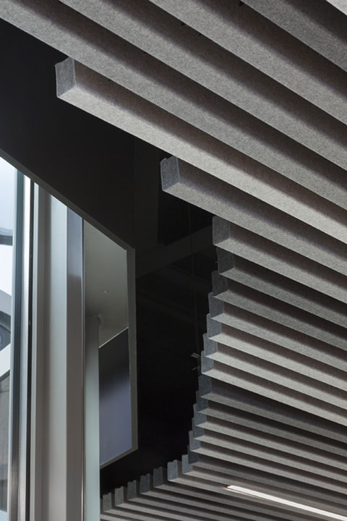
More product details
More detailed information can be found at the downloads section below. Here you can find information about: Maximum spans, dimension & weights, material requirement per m2

ACOUSTICS
Acoustic information
The acoustic comfort in an office space, school or public building contributes to our well-being as poor acoustic comfort can affect health, communication, safety, productivity and learning. Using Hunter Douglas high performance acoustical ceiling products are the best solution to deliver outstanding acoustic performance, comfort and an aesthetic pleasing solution. With the HeartFelt® ceiling absorption values (αw) between 0.45 (module 100) and 0.70 (module 50) can be achieved.

